## **Objectives**

* Explain React components
* Identify the differences between components and JavaScript functions
* Identify the types of components
* Explain class component
* Explain function component
* Define component constructor
* Define render() function

In this hands-on lab, you will learn how to:

* Create a function component
* Apply style to components
* Render a component

## **Prerequisites**

The following is required to complete this hands-on lab:

* Node.js
* NPM
* Visual Studio Code

## **Notes**

Estimated time to complete this lab: **30 minutes.**

Create a react app for Student Management Portal named scorecalculatorapp and create a function component named “CalculateScore” which will accept Name, School, Total and goal in order to calculate the average score of a student and display the same.

1. Create a React project named “scorecalculatorapp” type the following command in terminal of Visual studio:



1. Create a new folder under Src folder with the name “Components”. Add a new file named “CalculateScore.js”
2. Type the following code in CalculateScore.js

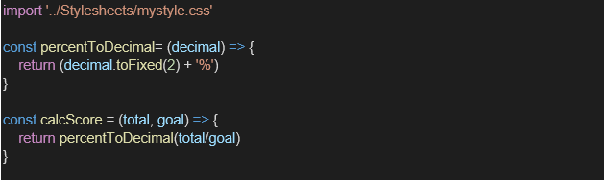

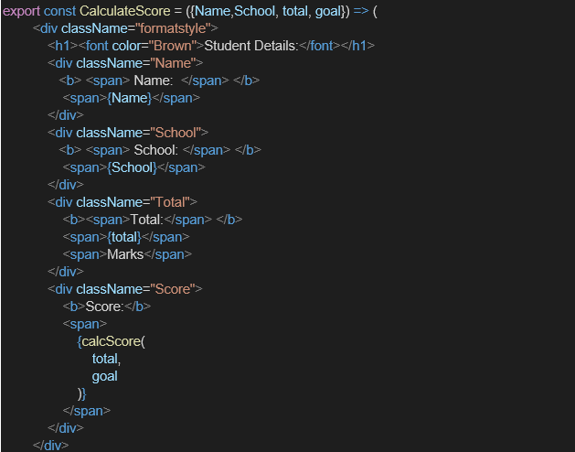

1. Create a Folder named Stylesheets and add a file named “mystyle.css” in order to add some styles to the components:

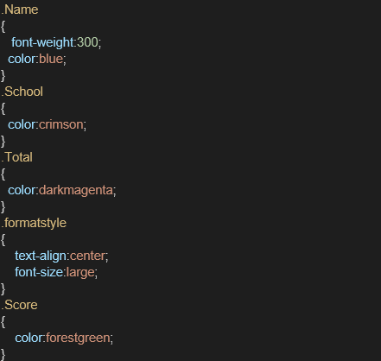

1. Edit the App.js to invoke the CalculateScore functional component as follows:

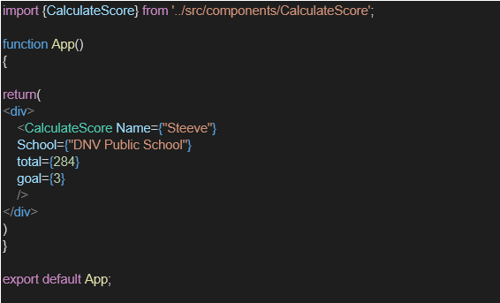

1. In command Prompt, navigate into scorecalculatorapp and execute the code by typing the following command:



1. Open browser and type “localhost:3000” in the address bar:

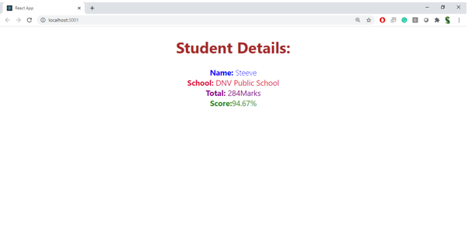

***Sample Code and Sample Output***

**App.js:**

import { CalculateScore } from "./Components/CalculateScore";

function App()

{

  return(

    <div>

      <CalculateScore Name={"Steve"}

      School={'ABC ENGINEERING COLLEGE'}

      total={456}

      goal={5}/>

    </div>

  )

}

export default App;

**CalculateScore.js**

import '../Stylesheets/mystyle.css'

const percentToDecimal=(decimal)=>{

    return (decimal.toFixed(2)+'%')

}

const calcScore=(total,goal)=>{

    return percentToDecimal(total/goal)

}

export const CalculateScore=({Name,School, total,goal})=>(

    <div className='formatstyle'>

        <h1><font color='Brown'>Student Details:</font></h1>

        <div className='Name'>

            <b><span>Name:</span></b>

            <span>{Name}</span>

        </div>

        <div className='School'>

            <b><span>School: </span></b>

            <span>{School}</span>

        </div>

        <div className='Total'>

            <b><span>Total: </span></b>

            <span>Marks</span>

        </div>

        <div className='Score'>

            <b><span>Score: </span></b>

            <span>{

            calcScore(total,goal)}</span>

        </div>

    </div>

)

**Mystyles.css**

Name{

    font-weight: 300;

    color: blue;

}

School{

    color: crimson;

}

Total{

    color: darkmagenta;

}

.formatstyle{

    text-align: center;

    font-size: large;

}

Score{

    color: forestgreen;

}

***Sample Output:***

